**Centre for Artificial Intelligence and Robotics (CAIR), DRDO, Bengaluru-93.**

Vasumathi M D, Research Scholar, ICE Department, NITT.

**DATA SHEET- WAIST ASSISTIVE POWERED EXOSKELETON**

**November-Monthly report**

**OBJECTIVE:**

To get the data sheet for the ILM-70x18 motor, HFUS-2SH-20 Gear drive and choose a suitable encoder for the Waist assistive powered Exoskeleton for bending, lifting and shifting during load carrying activity.

1. **Motor: ILM 70x18**

Details & Data sheet:

* Frameless motors for highest design flexibility
* Available with integrated safety brakes and encoders
* Hollow-shaft capability
* Extra-low voltage 12 V - 48 V
* Company Name: **TQ-RoboDrive, Germany,** [1]**.**

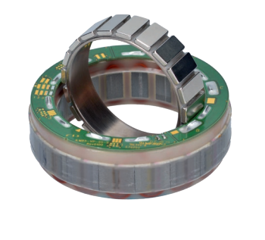

**Figure.1. Motor: ILM 70x18**

**Table.1.** DATA SHEET: **Motor: ILM 70x18**

|  |  |
| --- | --- |
| **Specifications** | **Units** |
| Max Power | 270 **[W]** |
| Rated voltage Ur * | 48 **[V]** |
| Rated torque Tr * | 1.24 **[Nm]** |
| Peak torque Tmax at 20% deviation from linearity | 4.05 **[Nm]** |
| Max rotation speed nmax** at Ur | 7,340 **[rpm]** |
| Diameter D | 69 **[mm]** |
| Length L | 30.5 **[mm]** |
| Weight m | 330 **[g]** |
| Number of pole pairs | 10 |
| Rotor inertia J | 0.321 **[kgcm2]** |
| Nominal operational temperature of the stator | -40°C to 125°C |
| * At nominal current. Thermal behavior is strongly dependent on installation situation. | |
| ** Theoretical no-load rotation speeds at Ur. Variations can arise from operation with different inverters. | |
| *** Max rotation speed due to mechanical structure. | |

**Web Address:** <https://www.tq-group.com/filedownloads/files/products/robodrive/data-sheets/en/DRVA_DB_Servo-Kits_ILM_EN_Rev408_Web.pdf>

1. **Encoder: RD70-AKSIM**

Details & Data sheet:

* Absolute magnetic multiturn encoder with hollow-shaft deign.
* RD70-AKSIM encoders provide accurate absolute position data with high resolution for the precise, efficient control of TQ-RoboDrive servo motors. The encoders feature highly robust magnetic ASIC sensors, providing significantly better resistance to dust, dirt and other disruptive elements. Multiturn cycle information is stored electronically but is not updated during motion when there is no power supply to the sensor.

▶ Hollow-shaft capability

▶ Flat off-axis system for space-constrained applications

▶ Singleturn resolution up to 262,144 incs/rev (18 bit)

▶ Multiturn resolution 65,536 revs (16 bit)

▶ Absolute accuracy ±0.1°, repeatability 0.002°, no hysteresis

▶ High speed operation up to 10,000 rpm

▶ Differential BiSS-C interface (update rate 28 kHz)

▶ Sampling rate 18 kHz

▶ Dimensions adapted to corresponding TQ-RoboDrive servo kits

* Company Name: **TQ-RoboDrive, Germany, [2].**

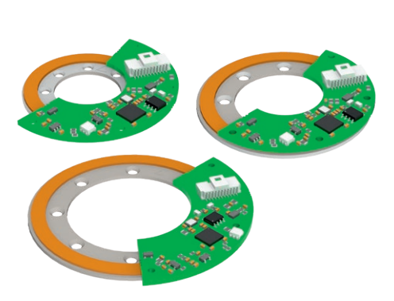

**Figure.2. Encoder: RD70-AKSIM**

**Table.2.** DATA SHEET: **Encoder: RD70-AKSIM**

|  |  |
| --- | --- |
| **Specifications** | **Units** |
| Singleturn resolution | 262,144 (18 bit) **[incs/rev]** |
| Multiturn resolution | 65,536 (16 bit) **[revs]** |
| Accuracy | ±0.1 **[deg]** |
| Repeatability | 0.0014 **[deg]** |
| Sampling rate fs | 18 **[kHz]** |
| Maximum rotation speed nmax | 7,000 **[rpm]** |
| Maximum acceleration amax | 60,000 **[rad/s²]** |
| Sensor PCB diameter D | 74 **[mm]** |
| Sensor length L | 9.2 **[mm]** |
| Weight m | 19.8 **[g]** |
| Inertia J | 0.070 **[kgcm²]** |
| Operational temperature range | -40°C to +105°C |
| Supply voltage Udd | 5 **[V]** |
| Supply current Idd | 150 **[mA]** |
| Communication interface* | BiSS-C differentia |

**Web Address:** <https://www.tq-group.com/filedownloads/files/products/robodrive/data-sheets/en/DRVA_DB_Sensors_RD50-70-85-AKSIM_EN_Rev404_Web.pdf>

1. **Gear Drive: HFUS-2SH-20**

Details & Data sheet:

* Simplicity Unit with hollow shaft.
* Supplied with no lubrication.
* Manufacturer: **Harmonic Drive AG, [3].**

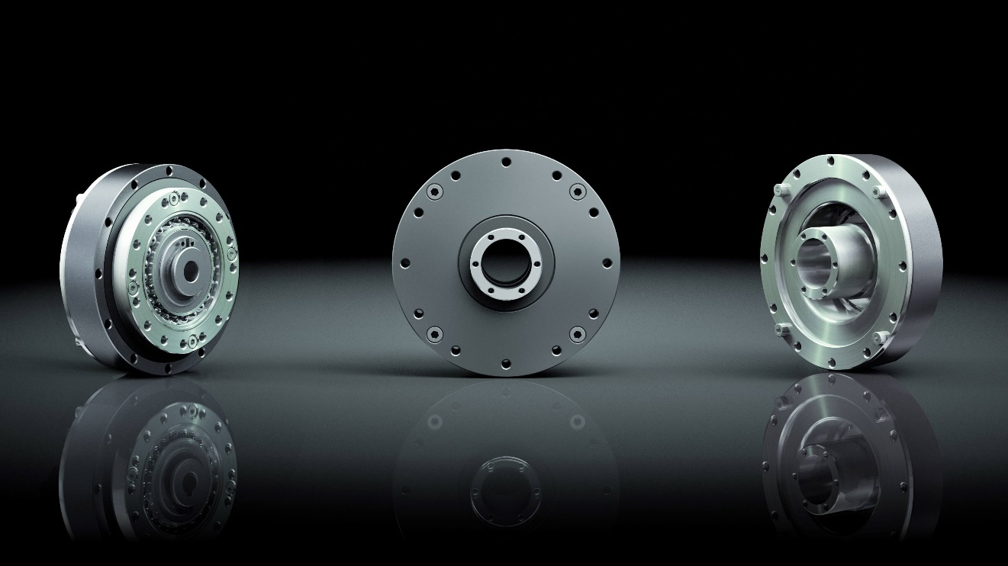

**Figure.3. Gear drive: HFUS-2SH-20**

**Table.3.** DATA SHEET: **Gear Drive: HFUS-2SH-20**

|  |  |
| --- | --- |
| **Specifications** | **Units** |
| Size | 20 |
| Outer Diameter | 90 **[mm]** |
| Reduction ratio | 50 |
| Max. Continuous torque | 34 **[Nm]** |
| Peak repetitive torque | 56 **[Nm]** |
| Hollow shaft diameter | 21 **[mm]** |
| Transmission accuracy | 1 **arc. min.** |
| Mass inertia | 404 **[gcm2]** |
| Max. Continuous input speed | 1100 **[rpm]** |
| Max. intermittent input speed | 6500 **[rpm]** |
| Inertia J | 0.070 **[kgcm²]** |
| Recommended temperature range | 0…+60°C |
| Weight | 1380 **[g]** |

**Web Address:** [**https://innodrive.ru/en/catalog/harmonic/gear/9299/**](https://innodrive.ru/en/catalog/harmonic/gear/9299/)

Reference:

[1] Data sheet for ILM70x18

[2] Data sheet for RD70-AKSIM

[3] Data sheet for HFUS-2SH-20